**Hack4NF October 15 – November 4**

**Challenge #3 - In silico drug target screening for NF**

*[method / approaches are available starting page 3]*

*Use this Box Link to get access to all input & code.*

[*https://bcm.box.com/s/084dua8kb02kq2s540fqwk0bmpn9ar7o*](https://bcm.box.com/s/084dua8kb02kq2s540fqwk0bmpn9ar7o)

**Background:**

One of the most common malignancies affecting adults with Neurofibromatosis type 1 (NF1) is the malignant peripheral nerve sheath tumor (MPNST),an aggressive and often fatal sarcoma that commonly arises from benign plexiform neurofibromas. MPNST, undifferentiated pleomorphic sarcoma, high-grade glioma, ovarian cancer, and melanoma appear to be more deadly in people with NF [1]. Currently, there is no targeted therapy for these patients.

**Observations:**

To understand the genomic landscape of this list of cancer [MPNST, undifferentiated pleomorphic sarcoma, high-grade glioma, ovarian cancer, melanoma] that appears more deadly in NF patients, I looked up several papers and did some observational analysis, which suggests Chr8q copy number gain seem to be a universal biomarker we could focus on.

Dehner and Moon et al. (2021) compared Tumor (T) and Xenograft (X) samples paired with tumor-adjacent normal samples (16 pairs) to describe the genomic landscape of MPNST. According to their CNV analysis, **chromosome 8q gain (chr8q+)** seems to be universal across most MPNST samples [**Figure. 1A & 1C**] compared to the benign tumors (plexiform nerofibromas) [**Figure 1B**].

**Figure 1: Chr8q gain is the most prevalent copy number variation in MPNST PDX.** (**A**) Copy number variation (CNV) plot of all 8 MPNST PDX pairs. (**B**) CNV plot of all 7 PN samples. (**C**) Representative CNV heatmap with hierarchical clustering of results from inferCNV analysis of scRNA-seq result of WU-356.

To investigate further, I looked up other cancers that could be a high risk for NF patients. I collected from ovarian cancer patients with CNV [**Figure 2**] and also from melanoma CNV cancer patients [**Figure 3**]. Both figures suggest there is a common chr8q+ that could be a biomarker of interest we can look for.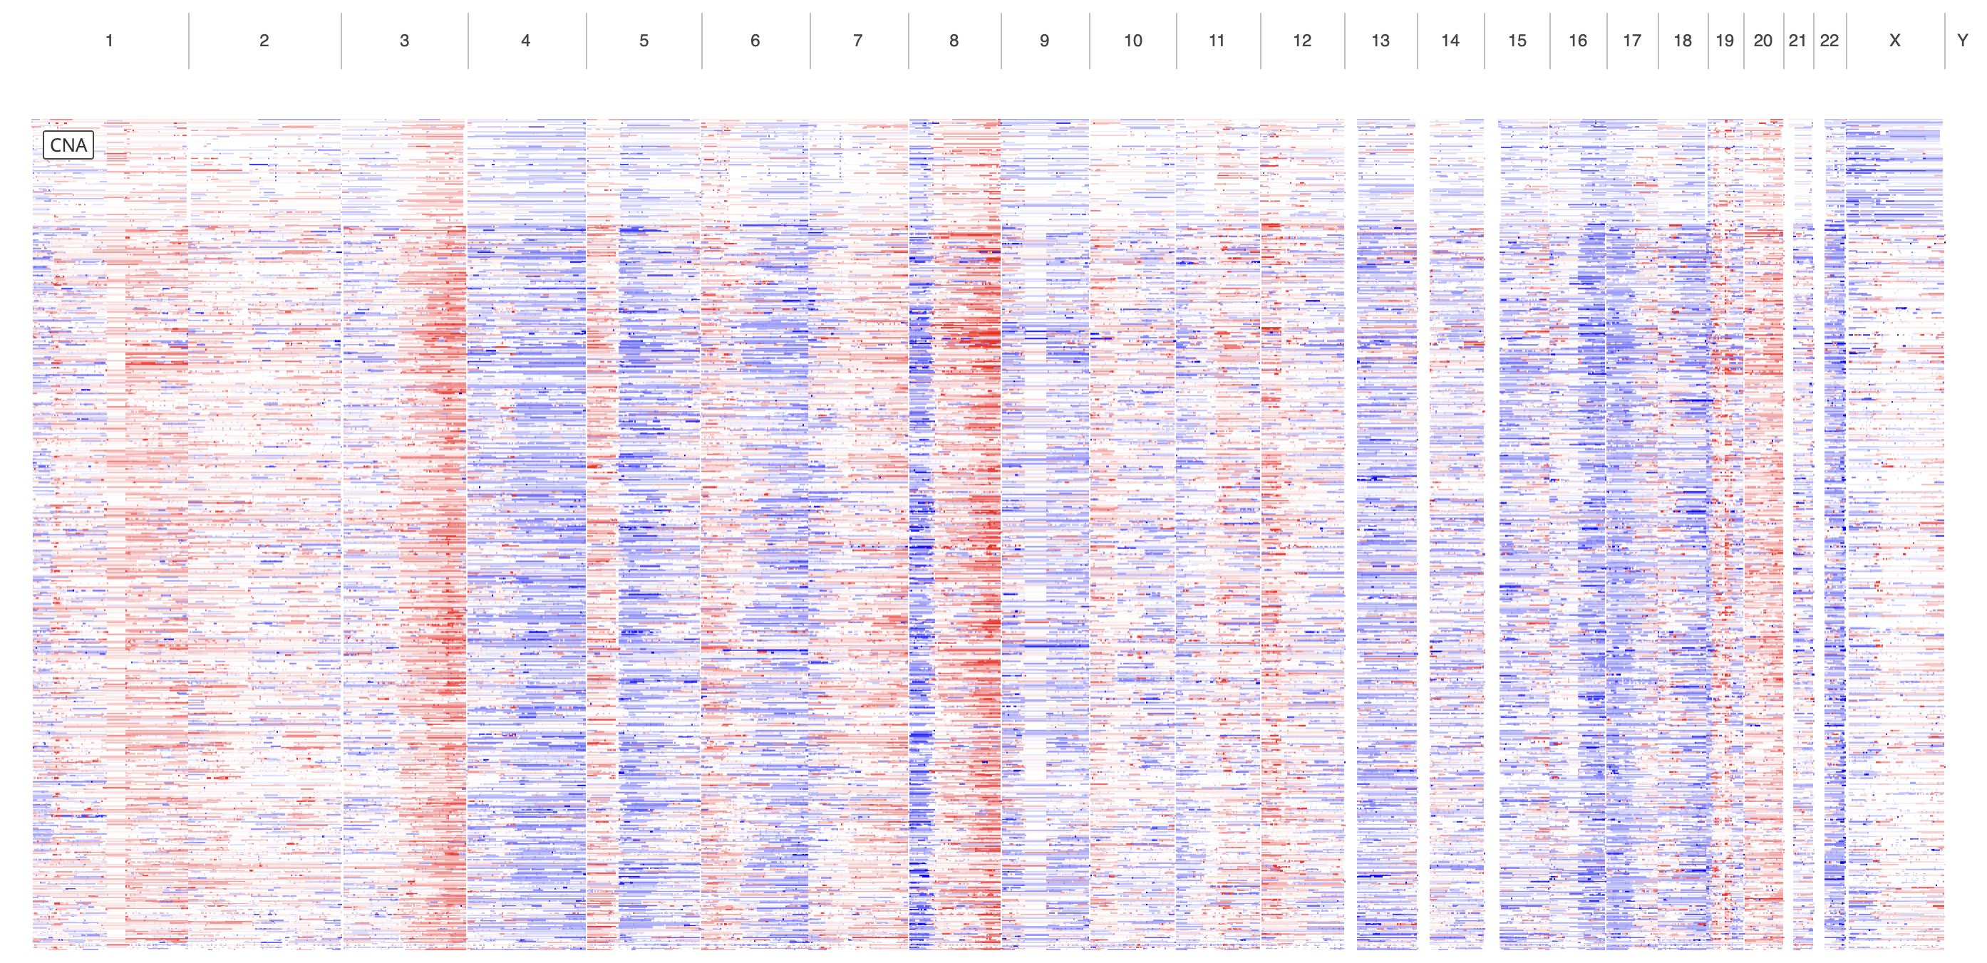

**Figure 2:** Ovarian CNV plot from 1909 samples from cBioPortal [3].

**Figure 3:** Melanoma CNV plot from 2835 samples from cBioPortal.

[1] “NF1 Associated with More Cancer Types Than Previously Known - NCI.” CgvBlogPost, April 20, 2021. Nciglobal,ncienterprise. <https://www.cancer.gov/news-events/cancer-currents-blog/2021/nf1-associated-with-more-cancer-types>.

[2] Dehner C, Moon CI et al. Chromosome 8 gain is associated with high-grade transformation in MPNST. JCI Insight. (2021)

[3] Cerami et al. The cBio Cancer Genomics Portal: An Open Platform for Exploring Multidimensional Cancer Genomics Data. Cancer Discovery. May 2012 2; 401. PubMed.

**Assumptions / Hypothesis:**

NF1-MPNST, Melanomas/Ovarian (NF-high-risk cancers) are commonly associated with chr8q+.

**Listing targetable/non-targetable drugs or gene knockouts that could be more sensitive toward NF patients with high-risk cancers can benefit the treatment responses.**

**Approach:**

**Step 1: Data collection**

I collected cell lines from the DepMap portal (<https://depmap.org/portal/>) which has a collection of 1800+ human cell lines drug screening and gene knockout data.

Based on the availability, I collected cell lines from the following cancer list:

**cell_line_id_melanoma_ovarian_mpnst.txt** 🡺 full list of cell line ID  
MPNST (n = 5)

Ovarian (n = 67)

Melanoma (n = 105)

From the DepMap Portal other input data are available.

**8q_Arm_level_CNAs.csv 🡺**

<https://depmap.org/portal/download/all/?releasename=DepMap+Public+22Q4&filename=OmicsCNGene.csv>

All cell line’s copy number variation data was log2 transformed with a pseudo-count of 1; log2(CN ratio + 1)].

**secondary-screen-dose-response-curve-parameters.csv 🡺**

<https://depmap.org/portal/download/all/?releasename=PRISM+Repurposing+19Q4&filename=secondary-screen-dose-response-curve-parameters.csv>

This file contains results of pooled-cell line chemical-perturbation viability screens for 1,448 compounds screened against 489 cell lines in an 8-step, 4-fold dilution, starting from 10uM.

**CRISPR_gene_effect.csv 🡺** <https://depmap.org/portal/download/all/?releasename=DepMap+Public+22Q4&filename=CRISPRGeneEffect.csv>

Gene Effect scores derived from CRISPR knockout screens published by Broad’s Achilles and Sanger’s SCORE projects. Gene Effect scores were inferenced by Chronos. Chronos is an algorithm for inferring gene knockout fitness effects based on an explicit model of cell proliferation dynamics after CRISPR gene knockout.

**Step 2: Wilcoxon rank sum test with the AUC scores from drug screening data**

Wilcoxon rank sum test is a non-parametric test that assumes that the differences between paired samples are not normally distributed.

Since samples cohort are independent, we used an unpaired Wilcoxon rank sum test for each treatment available.

Null hypothesis: Median of the chr8q-gain AUC and the chr8q-gain AUC are equal.

Alternative hypothesis: Median of the chr8q-gain AUC and the chr8q-gain AUC are different

**From** **DEPMAP_volcano.R**

Here is part of the volcano_input data table:

**name:** Drug name

**log10_adj_p_val**: Wilcoxon adjusted p-value (higher means more significant difference between median values of chromosome 8 gain vs no-gain)

**median_diff**: Drug median AUCs are calculated for both chromosome 8 gain cohort and no-gain cohort. Simply we subtract chromosome 8 gain to the no-gain cohort. Thus, negative values means the drug is more effective toward chromosome 8 gain cohort.

Here I defined groups based on my interpretation above.



Volcano plot can be created with the following code:

One can observe list of drugs that is more effective toward chromosome 8q gain based on the median AUC differences.

Top hits of the volcano plot can be converted into a bar graph that can show the top 10 effective drugs chr8q gain or no-gain.

Full list of drugs can be obtained with the following code:

**Step 3: Wilcoxon rank sum test with the AUC scores from gene effect**

Here we are using the CRISPR knockout gene effect scores to know which gene have an impact toward chr8q gain cohort.

Null hypothesis: Median of the chr8q-gain gene effect score and the chr8q-gain gene effect score are equal.

Alternative hypothesis: Median of the chr8q-gain gene effect score and the chr8q-gain gene effect score are different

**From** **DEPMAP_volcano_gene_effect.R**

Here is part of the volcano_input data table:

**name:** Gene symbol (entrez gene id)

**log10_adj_p_val**: Wilcoxon adjusted p-value (higher means more significant difference between median values of chromosome 8 gain vs no-gain)

**median_diff**: Median gene effect scores are calculated for both chromosome 8 gain cohort and no-gain cohort. Simply we subtract chromosome 8 gain to the no-gain cohort. Thus, negative values means the gene knockout will drop cell survivability toward chromosome 8 gain cohort cell lines.

Here I defined groups based on my interpretation above.



Similar to previous runs, volcano plots and barplots and table can be created with the code:

